|  |  |  |  |
| --- | --- | --- | --- |
| 1 | | 5,016.0 | |
| NUMERO DE FRONTERAS | | ENERGIA AGREGADA | |
|  | | | |
| SI | | 04/09/2020 | |
| CONTRATO | | VENCIMIENTO CONTRATO | |
|  | | | |
| 547,449 | 5 | | 20,587 |
| INGRESO 2019 | DÍAS CERTIFICADOS 2019 | | ENERGIA RESPALDADA 2019 |
|  | | | |
| 6,105,040 | 61 | | 234,646 |
| INGRESO 2020 | DÍAS CERTIFICADOS 2020 | | ENERGIA RESPALDADA 2020 |
|  | | | |
| 1,857,842 | 16 | | 80,235 |
| INGRESO 2021 | DÍAS CERTIFICADOS 2021 | | ENERGIA RESPALDADA 2021 |

|  |
| --- |
| **ESTELAR MILLA DE ORO**  USUARIO |

|  |
| --- |
| **Mateo Porras**  Ejecutivo de cuenta |

|  |
| --- |
| **Jorge Alfonso Millán Guevara / Gerente Corporativo de Soporte Técnico / jorgea.millan@hotelesestelar.com**  Primera fecha: PUNTO FOCAL |

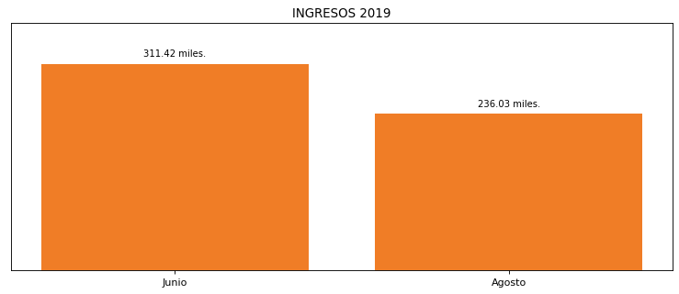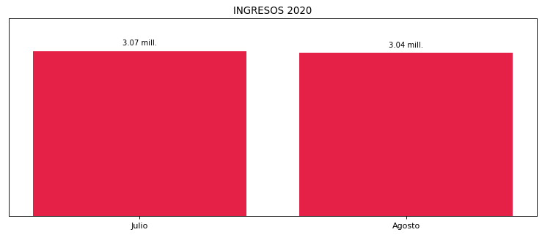

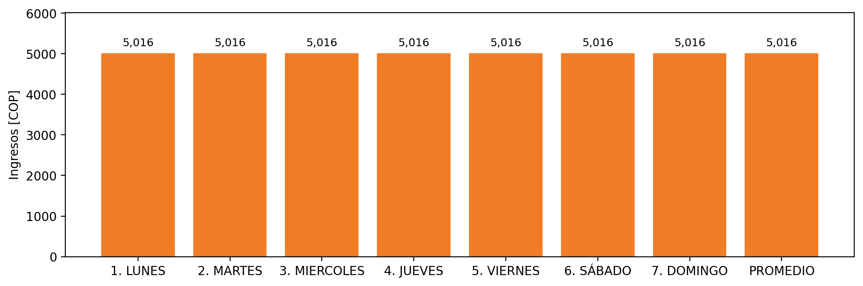

|  |  |  |  |  |  |  |  |  |  |
| --- | --- | --- | --- | --- | --- | --- | --- | --- | --- |
| **FRONTERA COMERCIAL** | **TIPO DDV** | **COD SIC** | **PREDIO** | **PROMEDIO** | **MARGEN** | **ÚLTIMA DESCONEXION** | **DÍAS CERTIFICADOS** | **ACTUALIZACION** | **PROXIMA PRUEBA DDV** |
| ESTELAR MILLA DE ORO | Frt38841 | Frt08135 | Prd02102 | 5,016 | NO APLICA | 2021-09-05 | 16.0 | 2026-04-15 | 2022-01-16 |